Installation Requirements for Development

Followings software installations are required for development of Java web application.

1. Java Installation
2. Maven Installation
3. Eclipse Installation
4. Tomcat server Installation
5. PostgreSQL Installation
6. Java Installation :

For installing java download latest version of java JDK from [www.oracle.com](http://www.oracle.com). It will download exe file for installation after that do following steps.

**Step 1: Double click on java executable file which you have downloaded.**

C:\Users\Admin\Desktop\Nikhil\javaEXE.PNG

**Step 2: The installation process is started .Windows security will ask you whether allow or not to run software. Click yes if asked.**

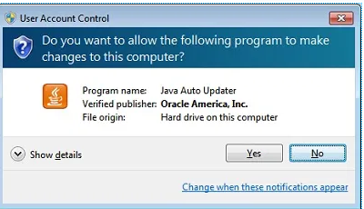

**Step 3: Click on Install button to accept license terms and start installation**.

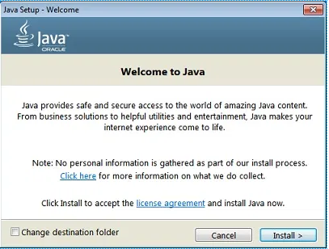

**Step 4: Now just do next > next > Finish.**

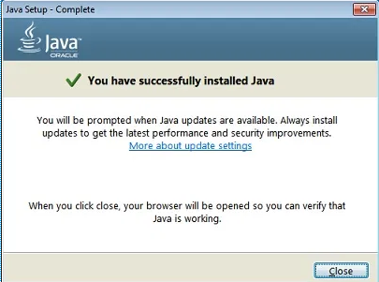

**SET JAVA PATH IN SYSTEM ENVIRNMENT VARIABLE**

In order to setting java path you need to open system variable windows first. To open system variable windows you follow these steps.

**Step 1: Right Click on My Computer, Computer or This PC and Select properties**.

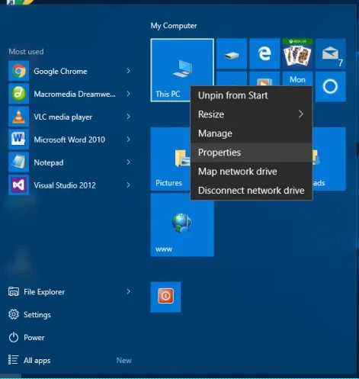

**Step 2: In the left side, there is link Advanced System Settings. Click on it.**

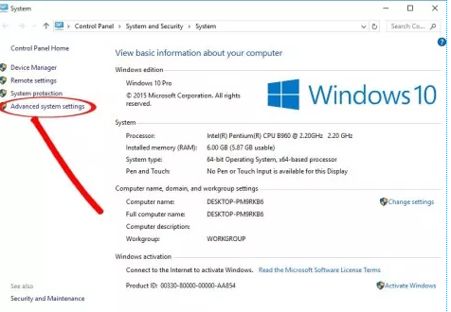

**Step 3: Go to Advanced tab and click on environment variables.**

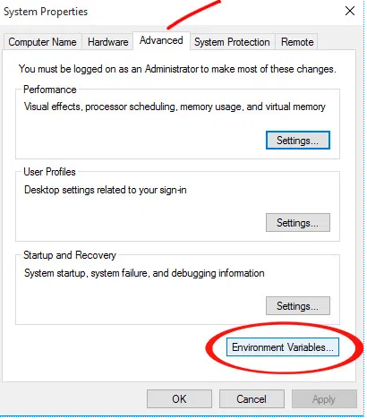

**Step 4: In System variable column click on New.**

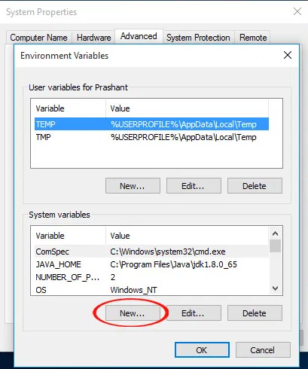

**Step 5: In the variable name write JAVA_HOME and in the variable value write java installation path it is in your program file location as C:\ProgrmeFiles\JAVA\jdk1.8.0 and click on ok to save.**

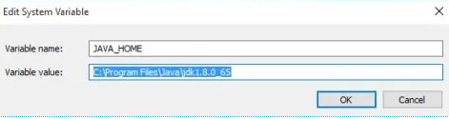

**Step 6: Now find Path in variable name and select it. Click on edit.**

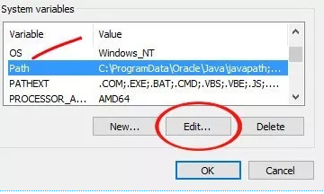

**Step 7: Add %JAVA_HOME%\bin at the end. You must put semicolon (;) at the end of previous value before adding new value. Then click ok to save.**

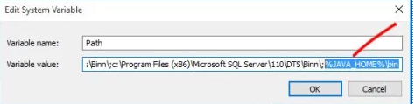

1. Maven Installation :

For installing maven download latest version of maven from <https://maven.apache.org> website .It will download maven zip file for installation after that do following steps.

**Step 1: Unzip the downloaded maven zip and place it in a drive containing all the java related artifacts. E.g.**  **D:\Java\apache-maven-3.2.5.**

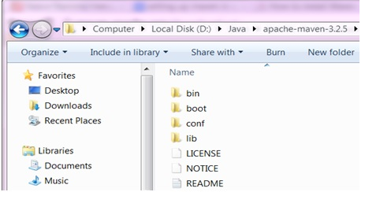

**Step 2: Now we need to set up the class path Maven (M2_HOME). Kindly ensure that the required version of the JDK has been installed.**

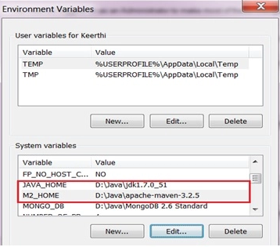

**Now edit the variable Path in the System variables to include the M2_HOME.**

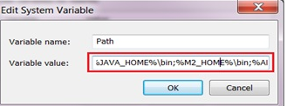

If the above steps are carried out successfully, then we are done with the maven installation and setup process of the maven tool. To check open command prompt from **Start🡪Command Prompt** and in command prompt just type maven command mvn –version.

1. Eclipse Installation :

For installing Eclipse download eclipse installer from  [http://www.eclipse.org/downloads](https://eclipse.org/downloads) website .It will download exe file for installation after that do following steps.

**Step 1: Double click on executable file which you have downloaded. The installation process is started .Windows security will ask you whether allow or not to run software. Click run if asked.**

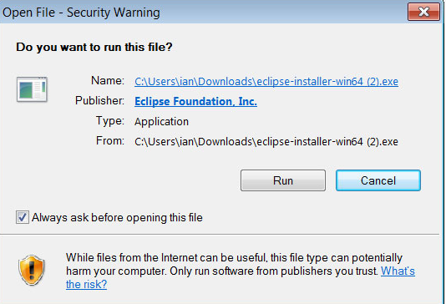

**Step 2 : Select the Packages to install.**

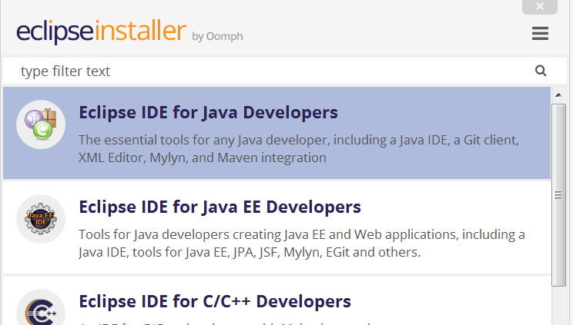

**Step 3: Select installation Folder.**

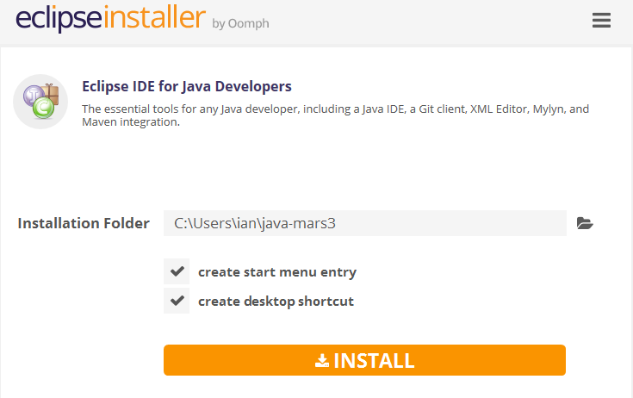

**Step 4: Launch Eclipse.**

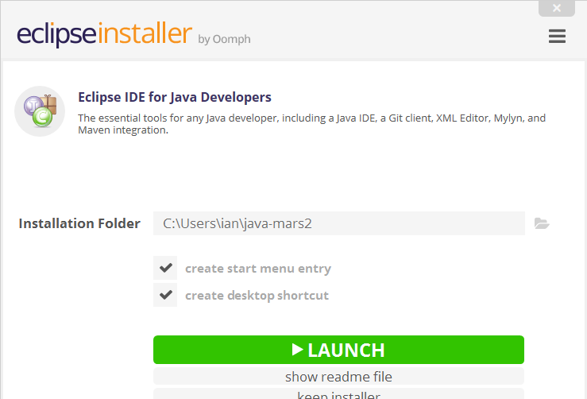

1. Tomcat server Installation :

For installing Tomcat download tomcat installer from [https://tomcat.apache.org](https://tomcat.apache.org/) website. It will download exe file for installation after that do following steps.

**Step 1: Double click on executable file which you have downloaded. The installation process is started. Click on Next button.**

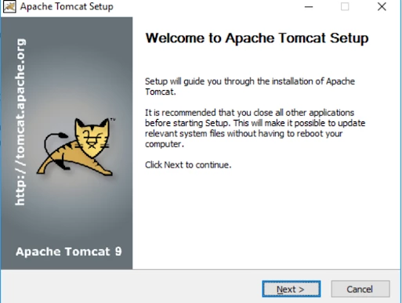

**Step 2: Before you can start the install, you must agree to the Apache License Agreement for the**[**Tomcat**](https://www.liquidweb.com/kb/how-to-install-oracle-java-8-in-ubuntu-16-04/)**9 service.**

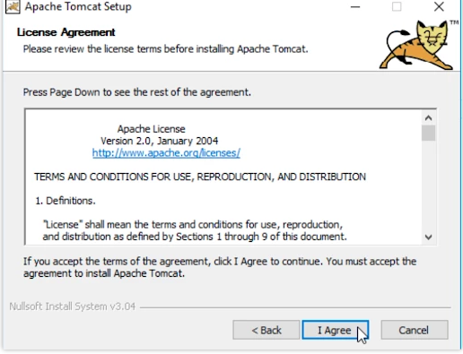

**Step 3: Click on “Select the type of install” dropdown list and choose the “**[**Full**](https://www.liquidweb.com/kb/how-to-install-oracle-java-8-on-ubuntu-14-04-lts/)**” install option and then click Next.**

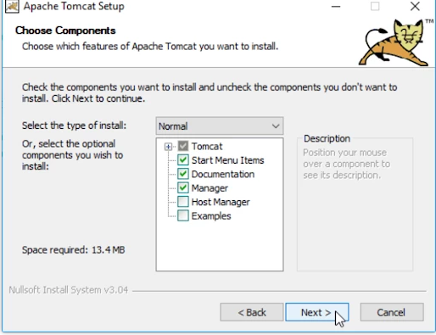

**Step 4: Configure your tomcat settings.**

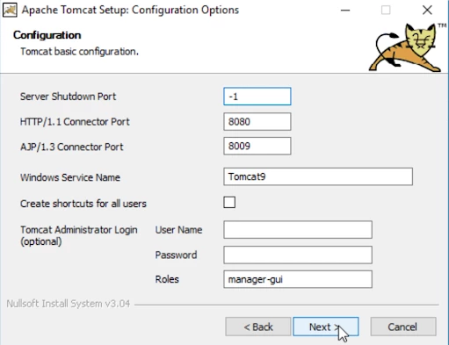

**Step 5: Next, you will choose the location where you want to install the**[**Tomcat**](https://www.liquidweb.com/kb/how-to-install-oracle-java-8-on-ubuntu-12-04-lts/)**9 service. Click Next.**

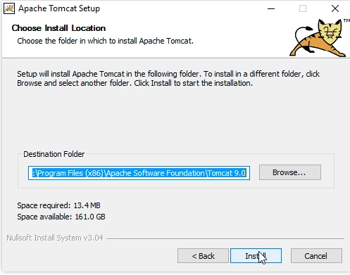

**Step 6: Select Java or JRE Path and click Next.**

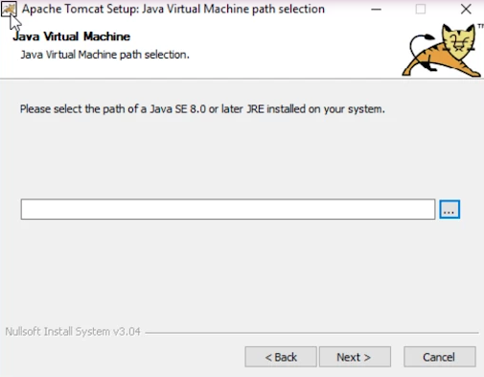

**Step 7: Once installation complete finish process.**

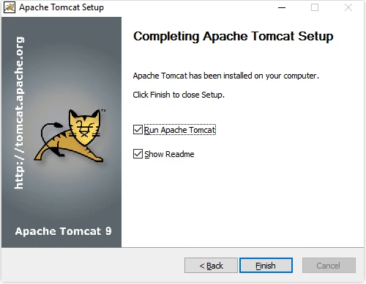

1. PostgreSQL Installation :

For installing PostgreSQL download installer from <https://www.enterprisedb.com/downloads/postgres-postgresql-downloads> website. It will download exe file for installation after that do following steps.

**Step 1: Double click on executable file which you have downloaded. The installation process is started. Click on Next button.**

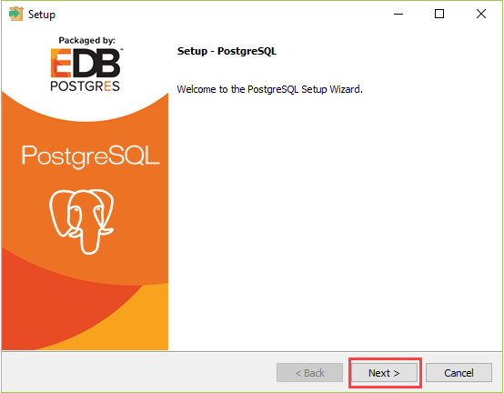

**Step 2**: **Specify installation folder, choose your own or keep the default folder suggested by PostgreSQL installer and click the Next button.**

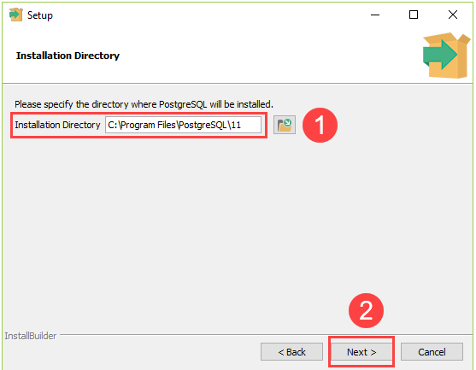

**Step 3: Select components to install and click the Next button.**

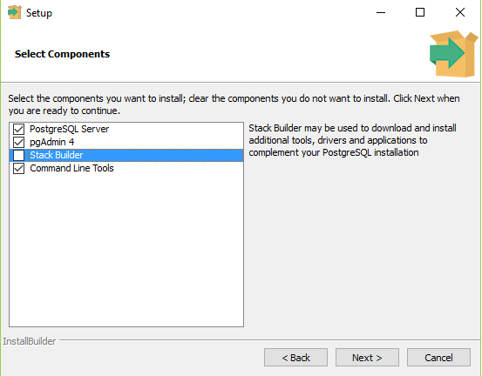

**Step 4: Select the database directory to store the data. Just leave it by default or choose your own and click the Next button.**

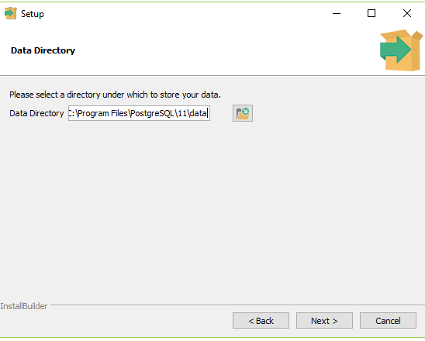

**Step 5: Enter the password for the database super user (postgres).**

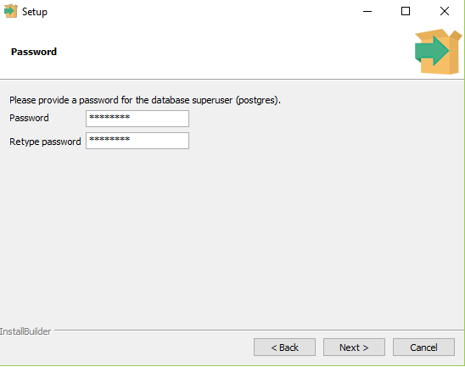

**Step 6: Enter the port for PostgreSQL. Make sure that no other applications are using this port. Leave it as default if you are unsure.**

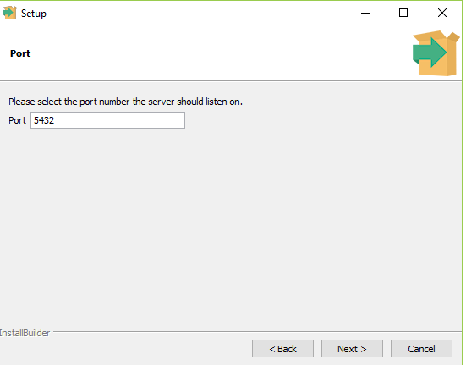

**Step 7:**  **Choose the default locale used by the database and click the Next button.**

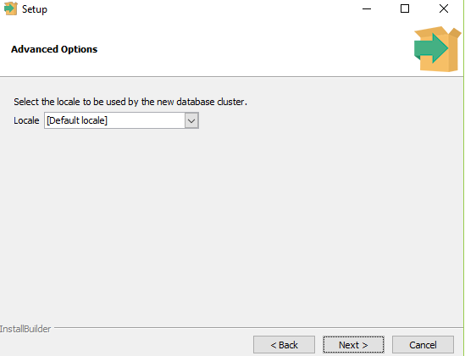

**Step 8: Ready to install PostgreSQL. Click the Next button to start installing.** **The installation may take a few minutes to complete.** **Click the Finish button to complete the PostgreSQL installation.**

